Chinook Music Store: User Manual
Developed by: Valeriia Lytovka | Banner ID: B01682412

Table of Contents
1. Welcome! 1
How to start 1
2. The Main Dashboard (Home) 3
• Search 3
• Alphabetical Order 4
• Track Count 4
3. Adding New Music (Insert) 5
• Album Title 5
• Artist 6
• Tracks 6
4. Viewing & Updating Details 7
• Details 7
• Update 8
• Save Changes 9
5. Deleting Safely 10
Quick Tips for Success: 11

- Welcome!
Welcome to the Chinook Album Manager. This tool is designed for store staff to easily manage our music catalog. You can add new albums, update existing info, or remove records that are no longer needed.
How to start:
- Open your terminal in the project folder.

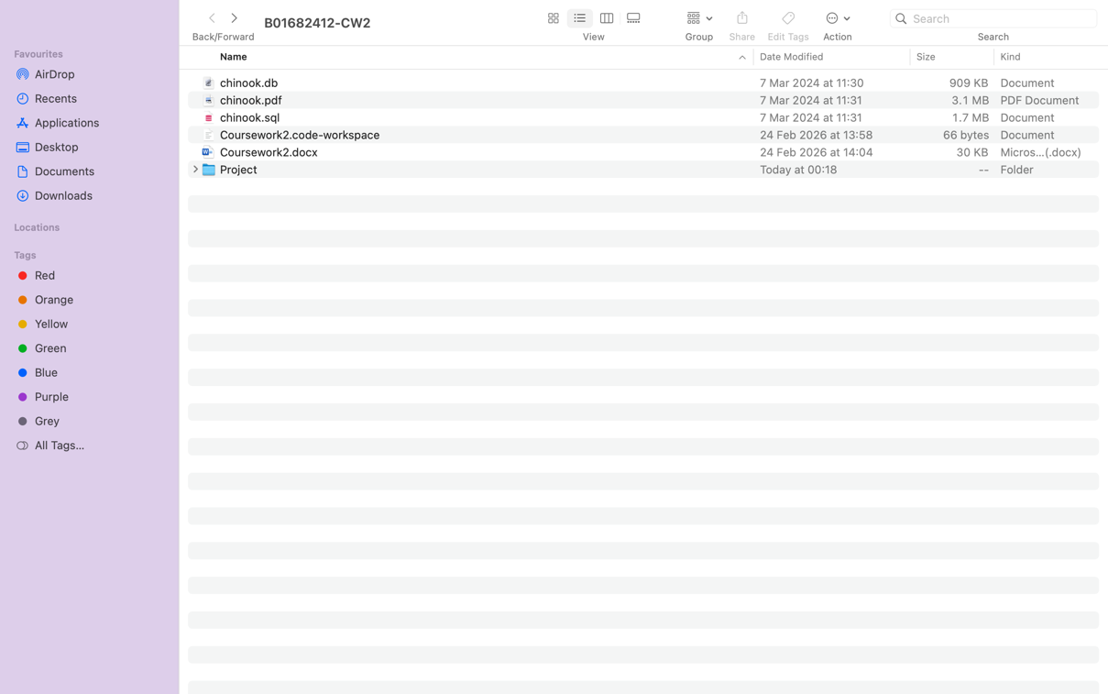
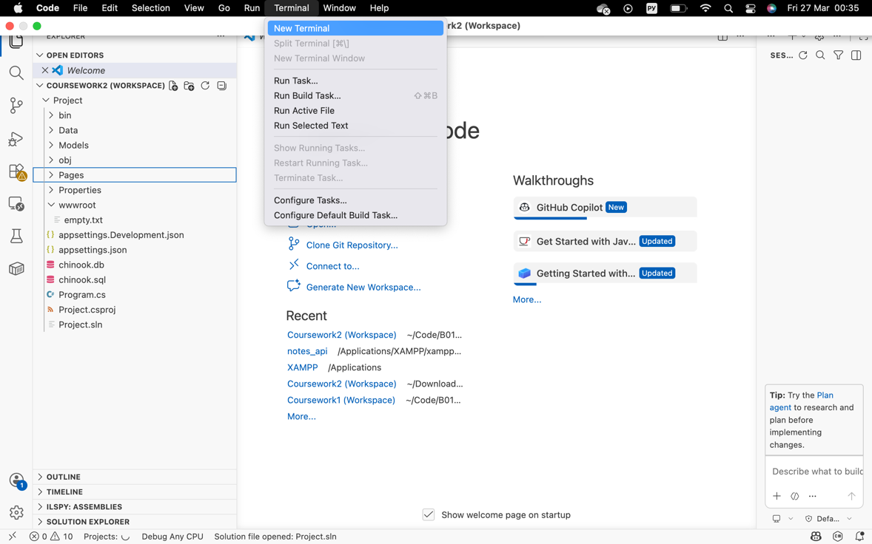

- Type dotnet run and press Enter.

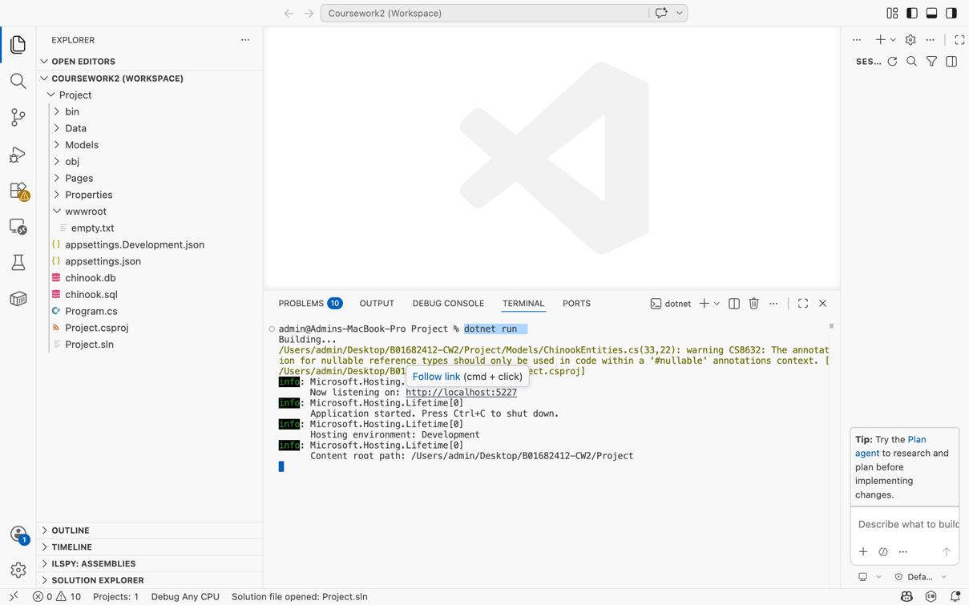

- Open your browser and go to: http://localhost:5227

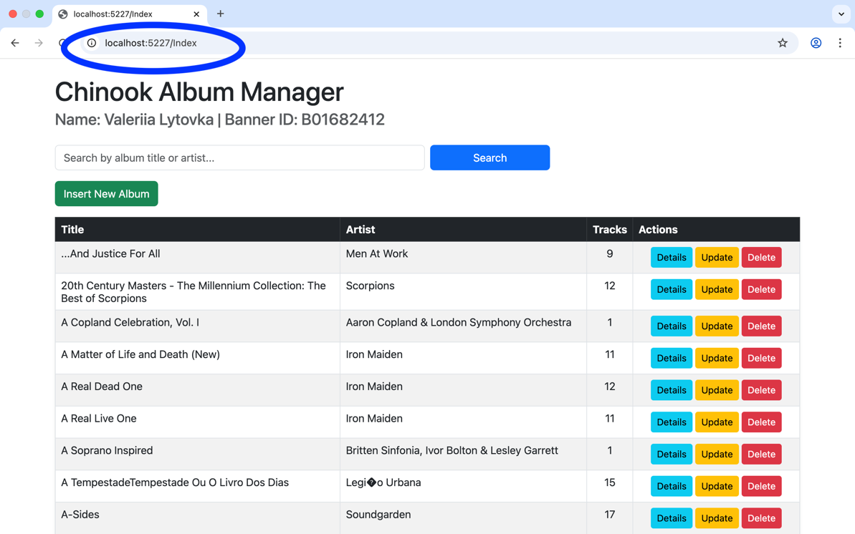

- The Main Dashboard (Home)
This is where you see everything we have in stock.
- Search: Use the search bar at the top to find an album or an artist quickly. Just type a name and hit "Search".

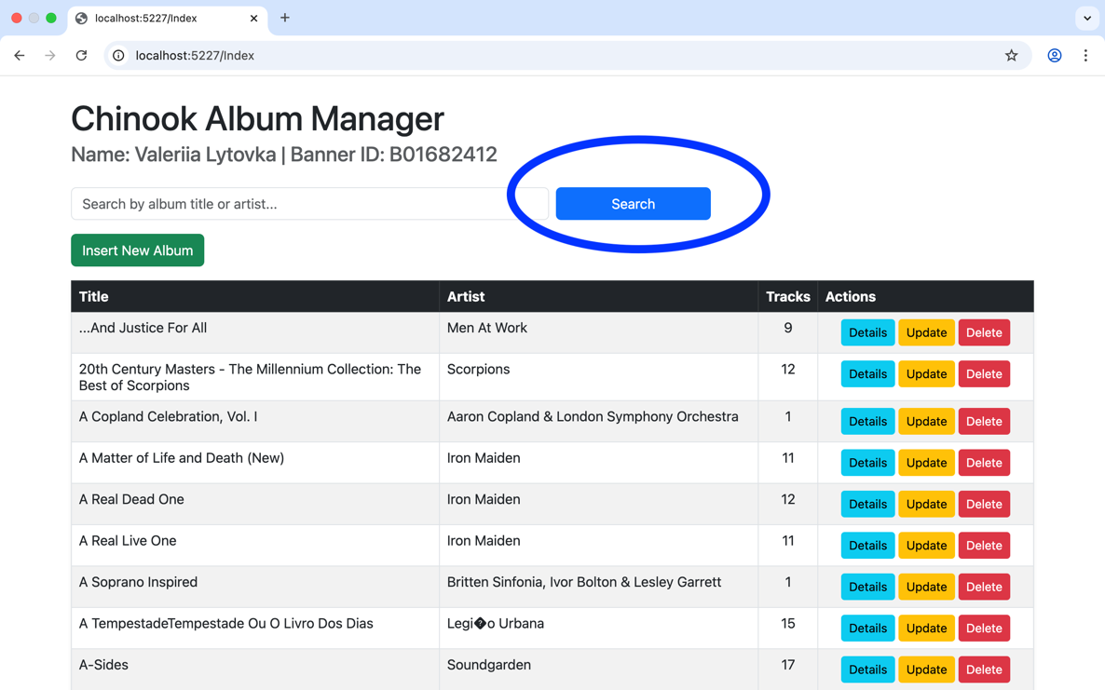

- Alphabetical Order: All albums are automatically sorted by their title so you don't get lost.

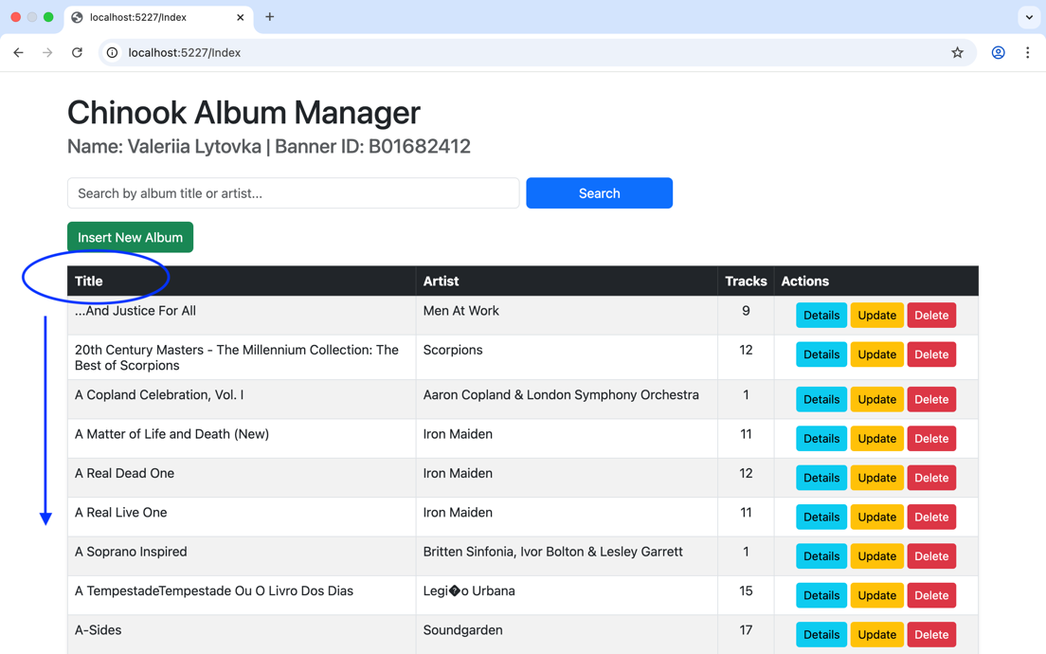

- Track Count: You can see how many songs are in each album right from the list.

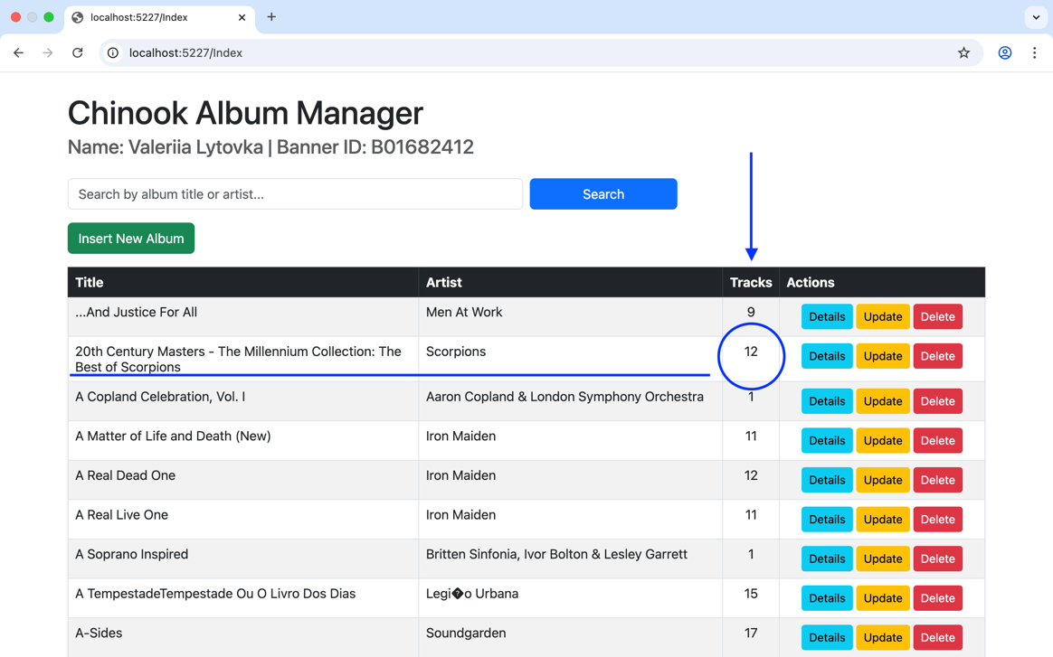

- Adding New Music (Insert)
Got a new shipment? Here is how to add it to the system:

- Click the green "Insert New Album" button.

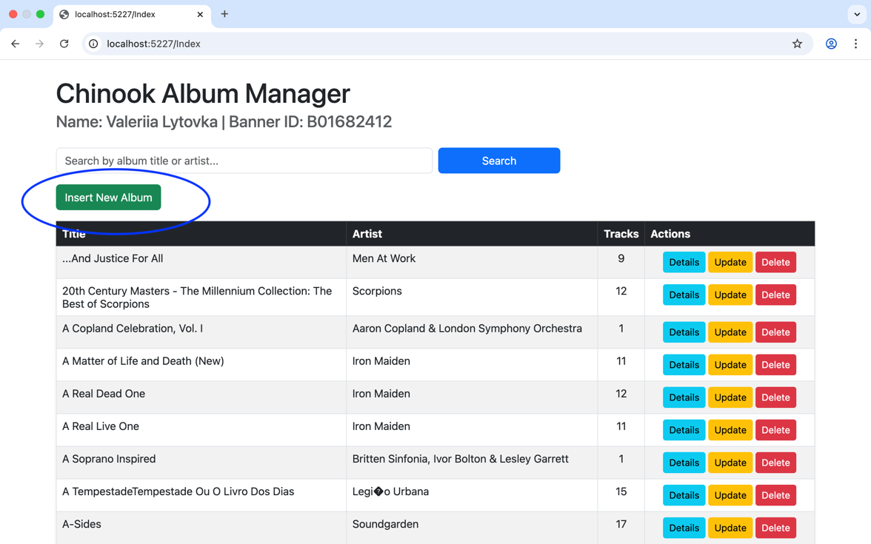

- Album Title: Type the name (be careful, max 160 characters!).

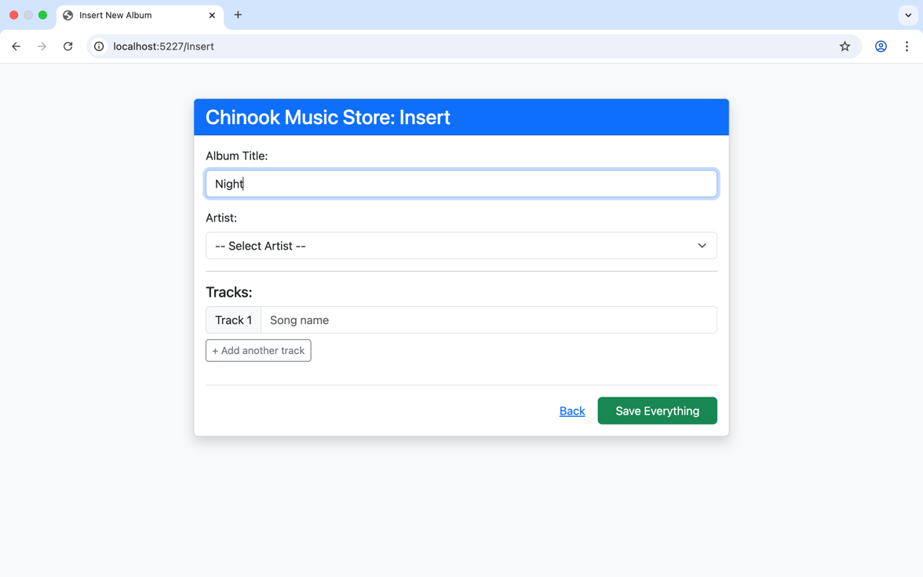

- Artist: Pick the artist from the dropdown list.

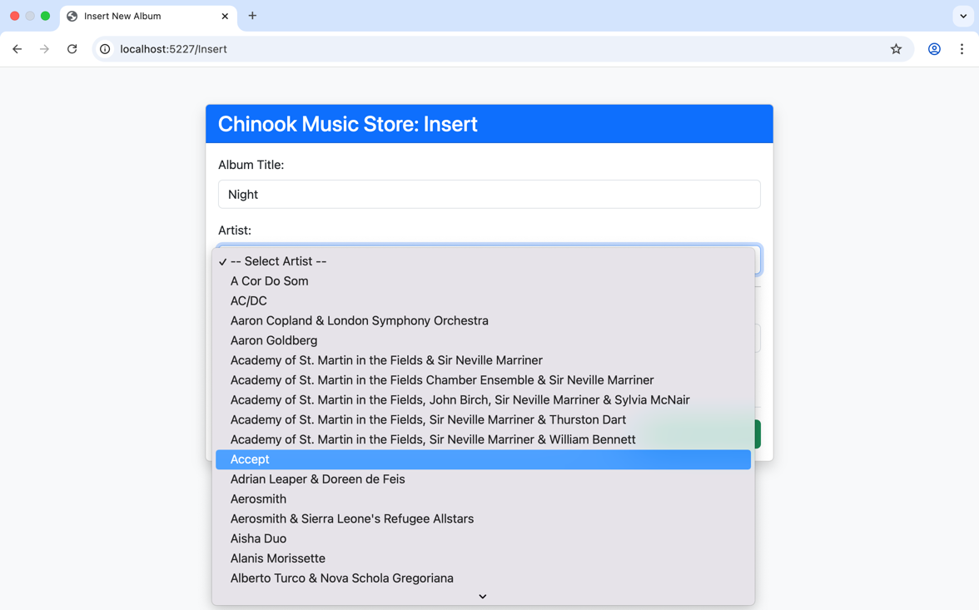

- Tracks: Type the song names. Need more? Click "+ Add another track".

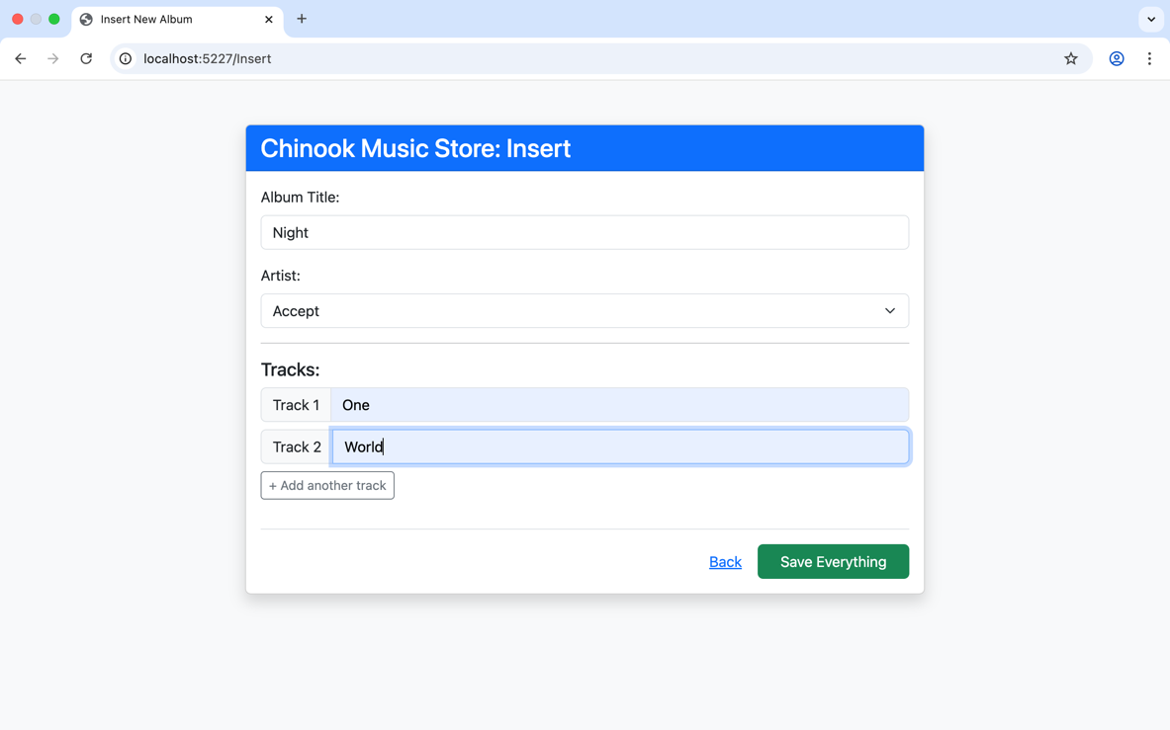

- Click "Save Everything".

- Viewing & Updating Details
Need to double-check a tracklist or fix a typo?

- Details: Click the blue button to see the full list of songs for any album.

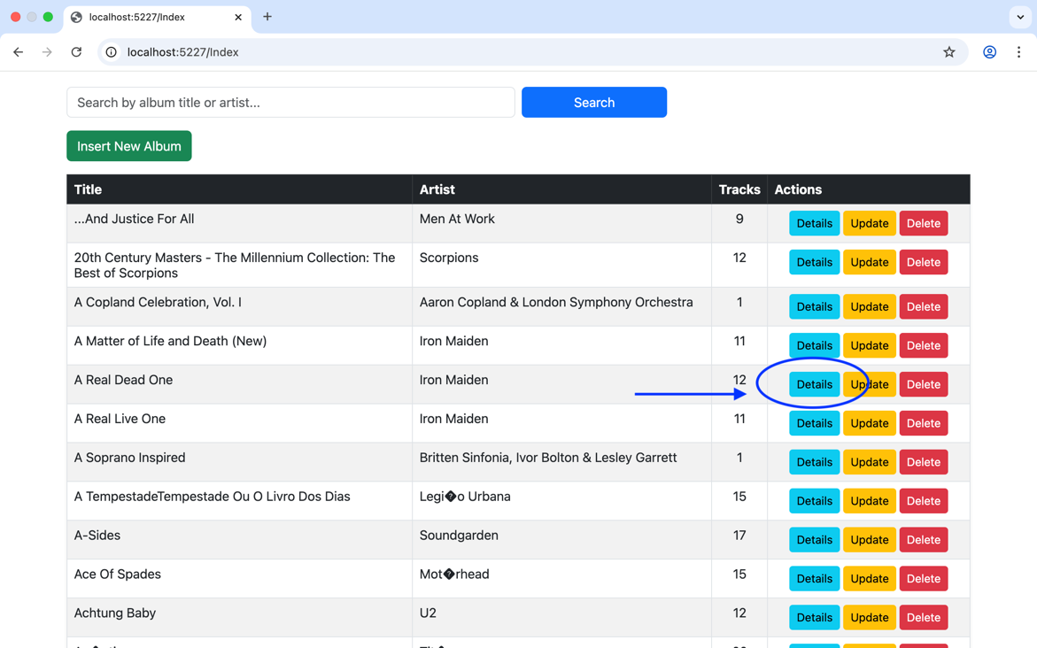

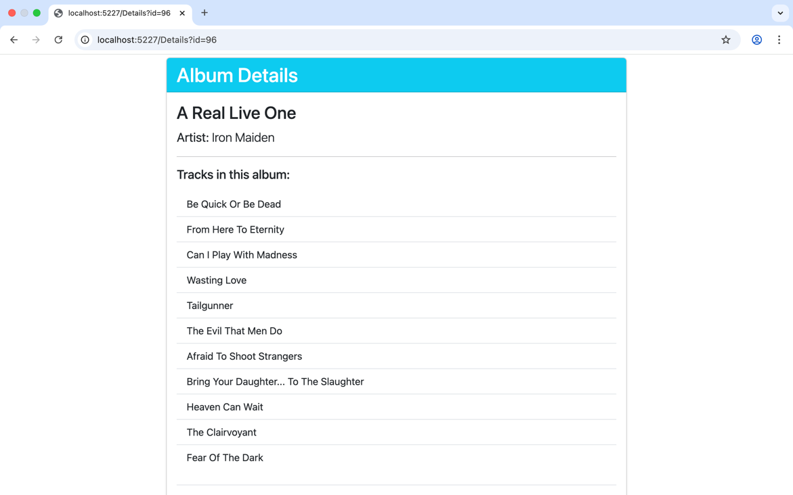

- Update: Click the yellow button if you need to rename the album, change the artist, or fix a song name.

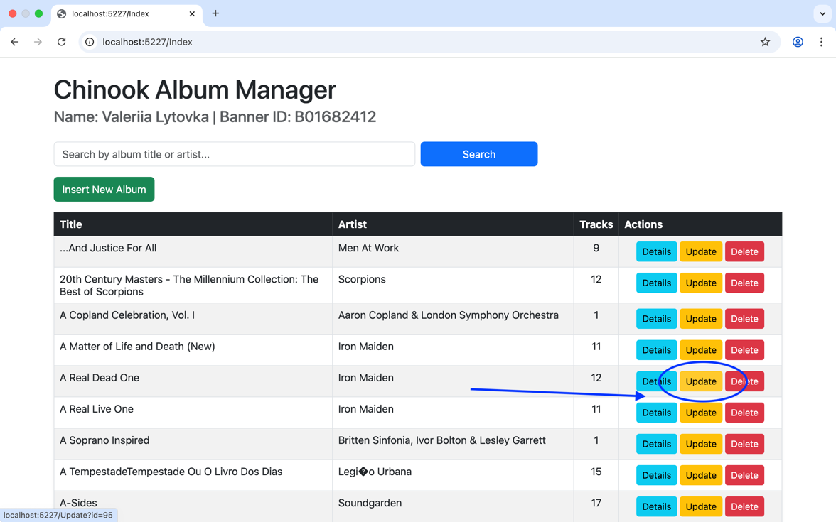

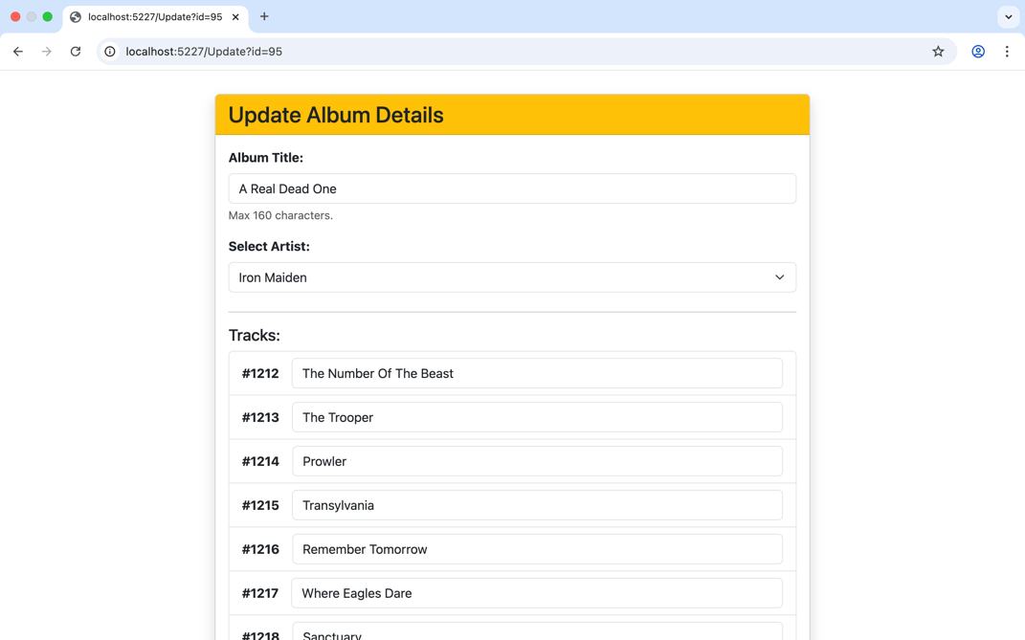

- Save Changes: Always click the blue button at the bottom to make sure your edits are saved to the database.

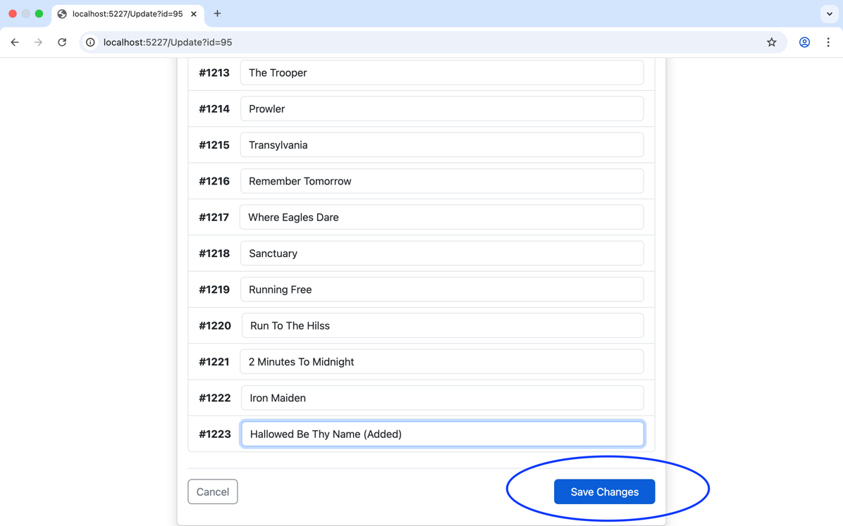

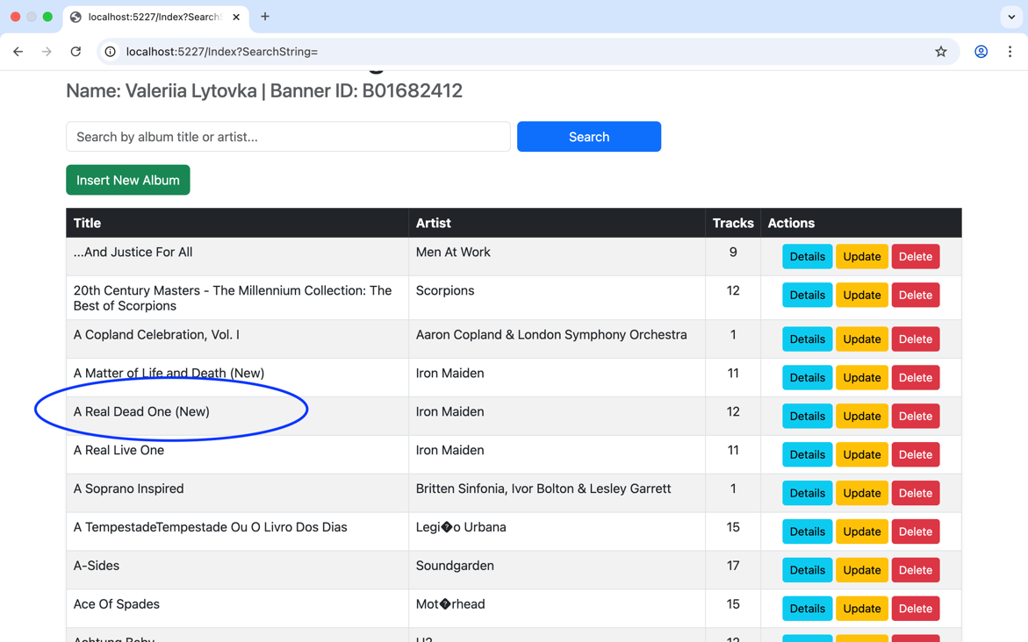

- Deleting Safely (The "Watch Out!" Part)
If an album is discontinued, you can remove it.
- Click the red "Delete" button.

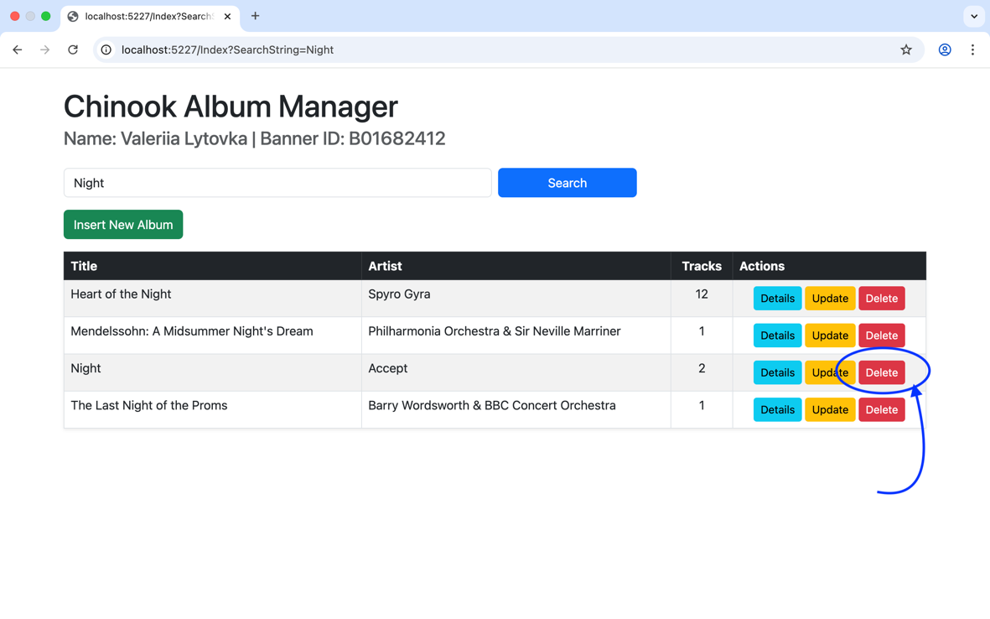
- The system will ask: "Are you sure?". This is your safety net!
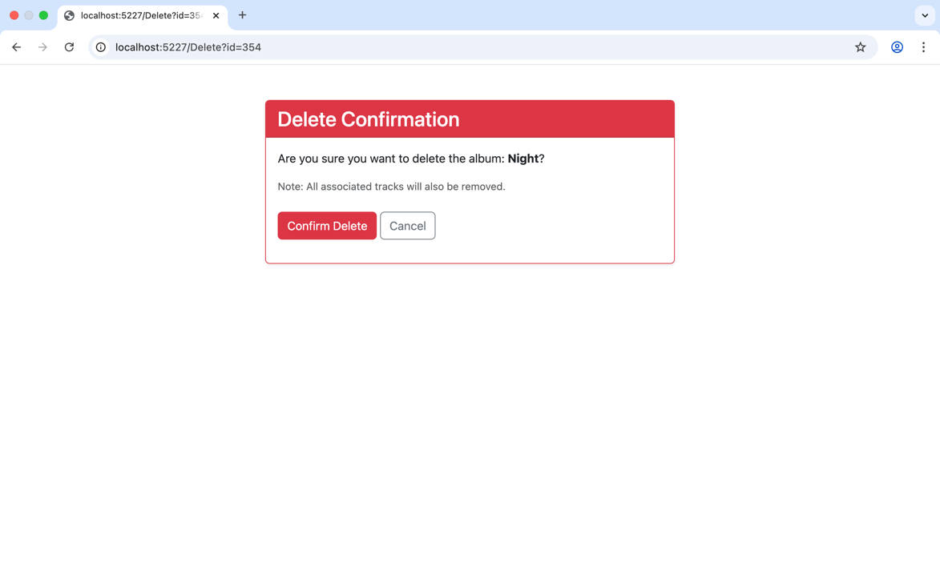
- Important: When you delete an album, all its songs are deleted too. This keeps our database clean.
- If you change your mind, just click "Cancel".

Quick Tips for Success:
- Required Fields: The system won't let you save an empty album title or an artist. It will show a warning if you forget.
- Navigation: Use the "Back to List" or "Cancel" links to return to the main page without saving changes.

